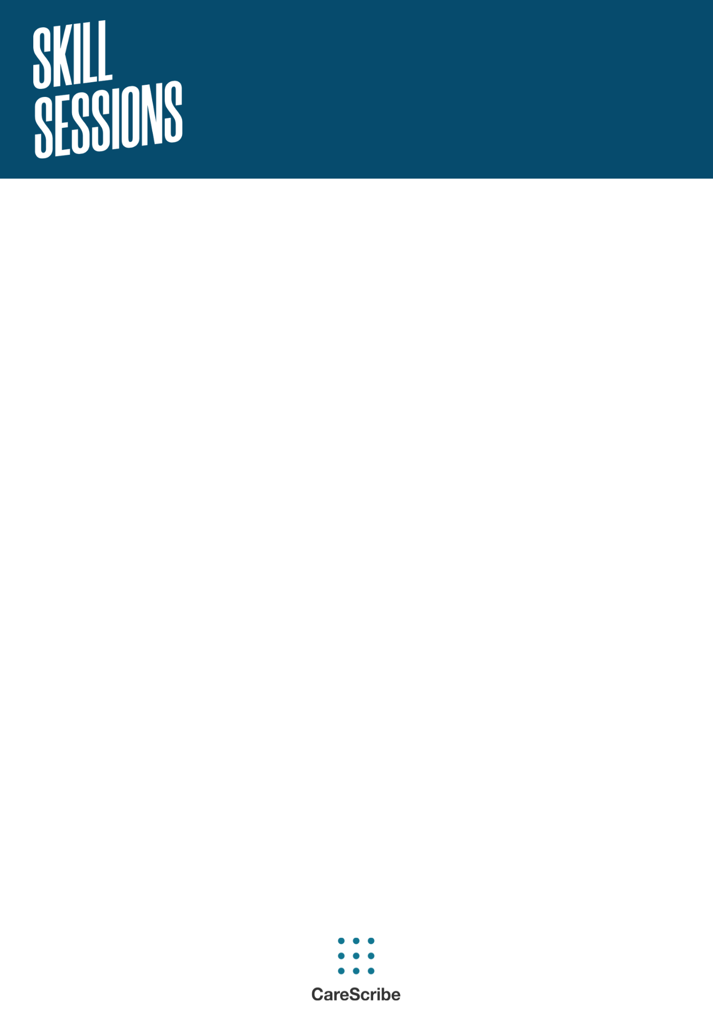

October 2024

**Menopause & Autism in the Workplace**

with Dr. Deborah Leveroy

**Additional Resources**

**Recommended resources from the talk:**

The Fawcett Society, Menopause Study, 2022: [Menopause and the Workplace (fawcettsociety.org.uk)](https://www.fawcettsociety.org.uk/menopauseandtheworkplace#:~:text=Our%20report,%20Menopause%20and%20the%20Workplace,%20sponsored%20by)

Bridging the silos: AutisticMenopause.com

The project asks how autistic people experience menopause and how they can better access information, services, and supports that might help them

Science on the spectrum: Dr Rachel Moseley <https://www.scienceonthespectrum.net/>

Her research focuses on understanding the challenges faced by autistic people, primarily around  mental  health.

The Knowledge GP Dr Nighat Arif - this book encompasses all experiences, including the perspectives of women of colour, people of all abilities and cultures, and the transgender community to ensure that all groups affected by female health concerns are a part of conversations.

National Autistic Society has produced new advice and guidance on menopause and a downloadable Autism and menopause guide: [NAS_MenopauseGuide.pdf (thirdlight.com)](https://nas.chorus.thirdlight.com/file/24/GgMt7wYGg3ddx69GgNycGVNM911/NAS_MenopauseGuide.pdf)

**Academic Research Papers mentioned in the talk:**

To address the question of menstruation, see:

Steward, R., Crane, L., Roy, E., Remington, A., & Pellicano, E. (2018). “Life is Much More Difficult to Manage During Periods”: Autistic Experiences of Menstruation. Journal of Autism and Developmental Disorders, 48(12), 4287-4292.

Simantov, T., Pohl, A., Tsompanidis, A., Weir, E., Lombardo, M., Ruigrok, A., Smith, P., Allison, C., Baron-Cohen, S., & Uzefovsky, F. (2021). Medical symptoms and conditions in autistic women: . Autism: The International Journal of Research and Practice, 26(2), 373-388.

Articles on hormonal balance:

Gasser B. A., Kurz J., Dick B., Mohaupt M. G. (2020). Are steroid hormones dysregulated in autistic girls? Diseases, 8(1), Article 6. <https://doi.org/10.3390/diseases8010006>

Pohl A., Cassidy S., Auyeung B., Baron-Cohen S. (2014). Uncovering steroidopathy in women with autism: A latent class analysis. Molecular Autism, 5, Article 27. <https://doi.org/10.1186/2040-2392-5-27>

Articles on physical sensations:

Bonete S, Molinero C, Ruisanchez D. Emotional Dysfunction and Interoceptive Challenges in Adults with Autism Spectrum Disorders. Behav Sci (Basel). 2023 Apr 5;13(4):312. doi: 10.3390/bs13040312. PMID: 37102826; PMCID: PMC10136046.

Articles on autism and (peri)menopause:

Groenman, A. P., Torenvliet, C., Radhoe, T. A., Agelink van Rentergem, J. A., & Geurts, H. M. (2022). Menstruation and menopause in autistic adults: Periods of importance? Autism, 26(6), 1563-1572. <https://doi.org/10.1177/13623613211059721>

Moseley RL, Druce T, Turner-Cobb JM. 'When my autism broke': A qualitative study spotlighting autistic voices on menopause. Autism. 2020 Aug;24(6):1423-1437. doi: 10.1177/1362361319901184. Epub 2020 Jan 31. PMID: 32003226; PMCID: PMC7376624.